COSC 250 - MicroComputer Organization

Name Jeremy Scheuerman

Show your work or the exercise it will be graded with 0 points

“*If I cannot read I cannot grade*” remember!

1. Describe the Memory Subsystem in the Von Neumann Architecture (2 points)

-for fetch it retrieves the memory from the address decodes and then copys it into MDR,for store it loads the address, loads the value decodes it, then copys the content into a specific memory address location

1. Briefly discuss the following terminologies (5 points)

PLA – Programmable Logic array, a programmable logic device used to implement combinational logic circuits

Sequential Circuit -consists of logic gates whose outputs at any time are determined by current and past input values., almost has a memory of sorts

Micro-Architecture –has basic functions of a cpu, memory unit and I/O or input output, gives instructions to cpu

Volatile Memory –Memory that is erased once the machine loses power

Digital System –a device that can read write or store information that is represented in numerical form

1. Convert the following Decimal numbers to Binary, Octal and Hexadecimal (6 points)
2. 37

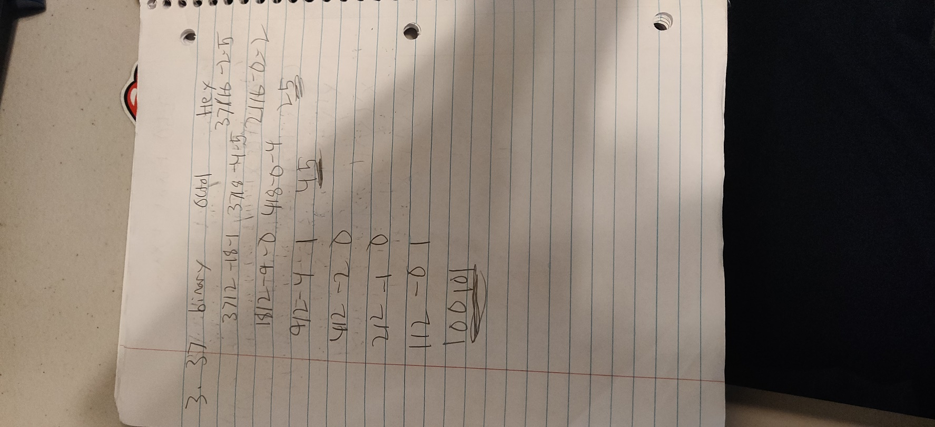

1. 2020

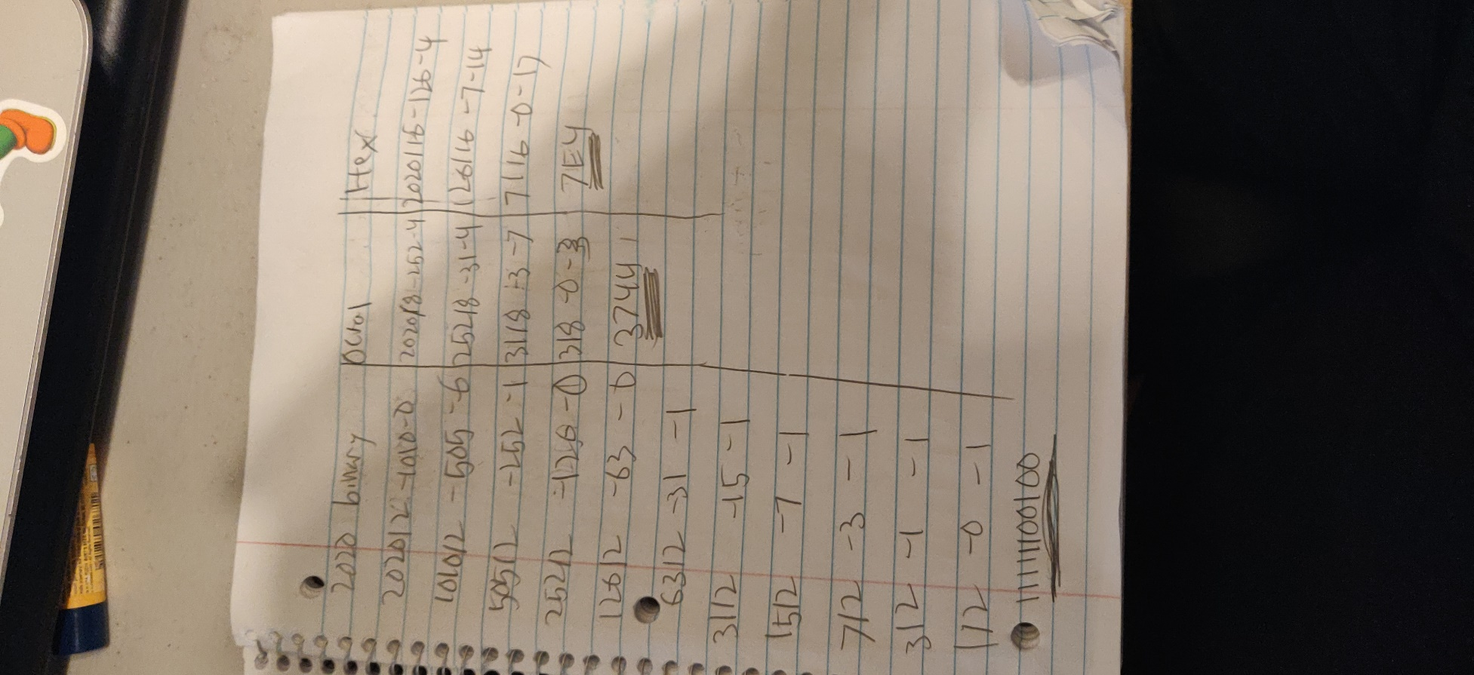

1. Two’s complement format is used for encoding an integer number in a modern computer system. Let’s assume that 8 bits are used to save an integer in the computer system. How **-20** is encoded in the 8 bit memory location? (6 points)

How the same number will be store in the 8 bit memory location using the Sign and

Magnitude format?

How the same number will be store in the 8 bit memory location using the One’s

Complement format?

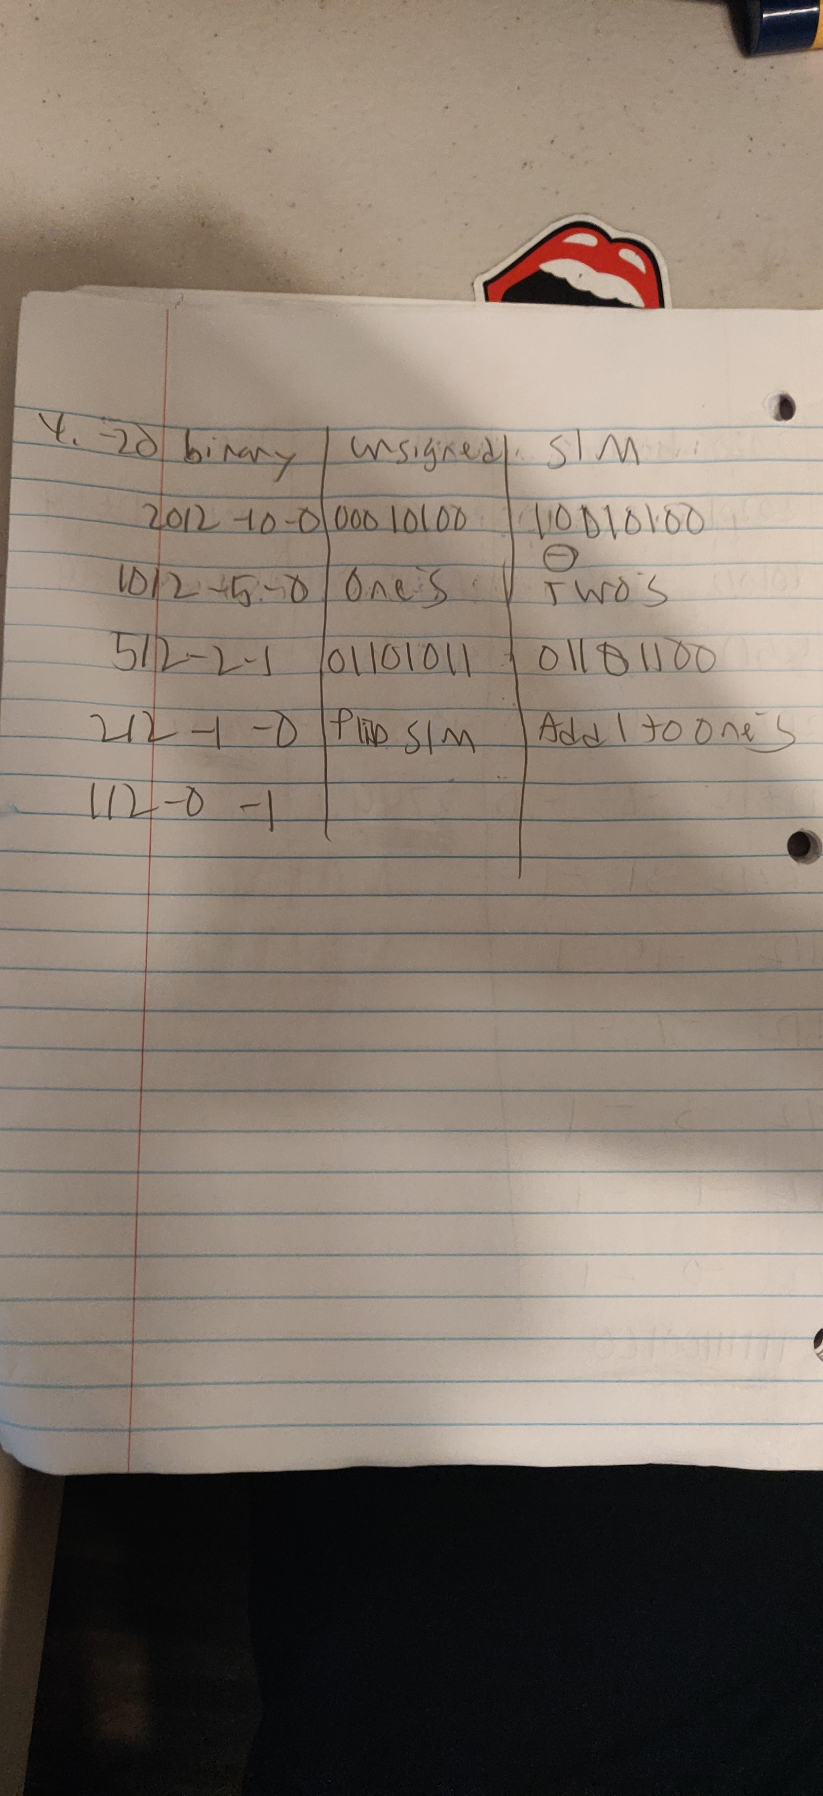

1. Two’s complement format is used for encoding an integer in a modern computer system. Let’s assume that 16 bits are used for saving an integer in the system. An encoded binary code **1111111111011001** is saved for an integer value in a memory. What is the decoded value? (3 points)
   1. -21
   2. -39
   3. 32
   4. -37
   5. **None of above** -this one

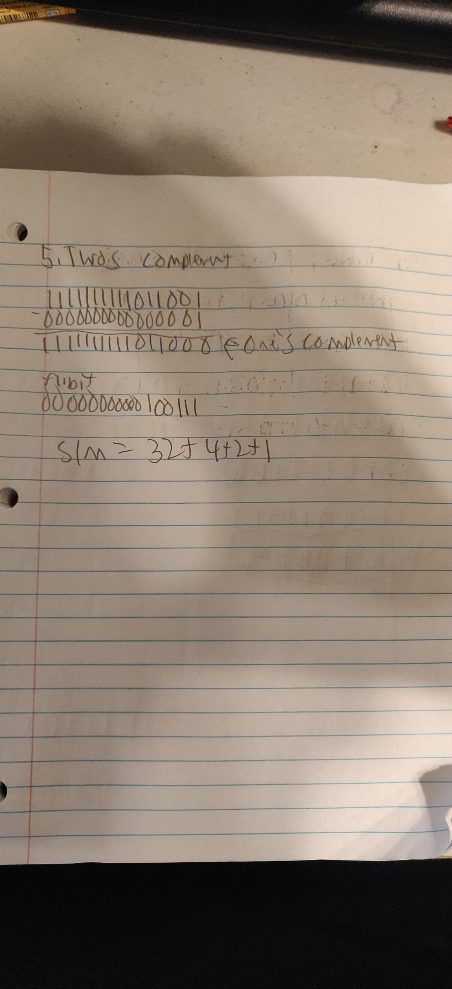

1. Simplify the following Boolean expressions by using algebraic manipulation (10 points)
   1. 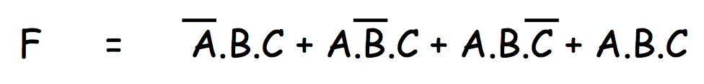



* 1. 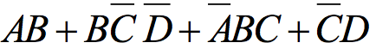



1. Simplify following Boolean function in **sum of product form** and **product of sum form** by only using K-map (15 points)

a) $F\left(W,X,Y,Z\right)=\overline{W}\overline{Y}\overline{Z}+\overline{W}X\overline{Y}Z+WXZ+\overline{X}\overline{Z}+WY\overline{Z}$

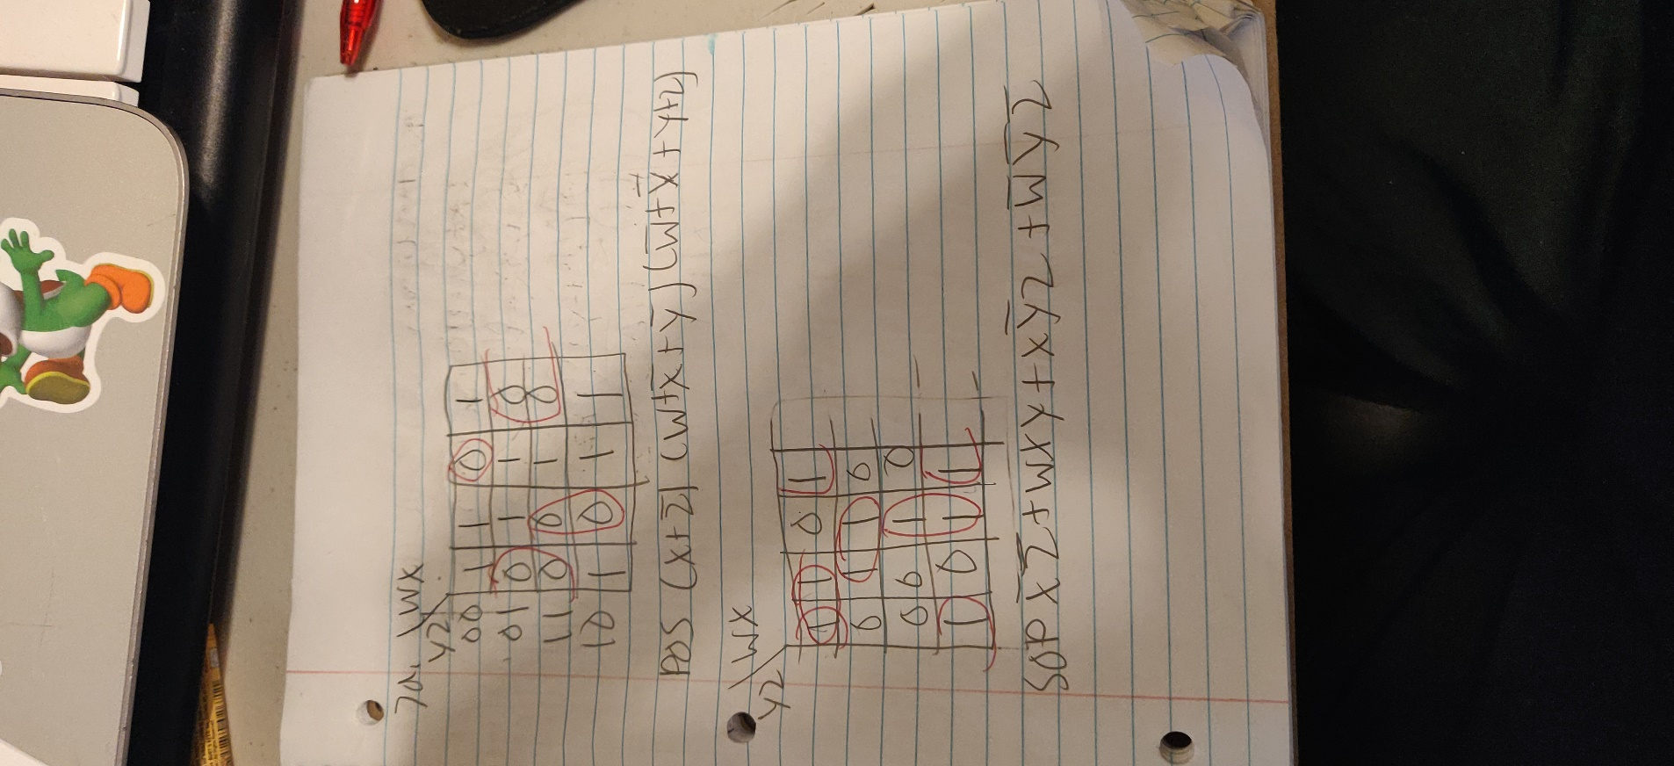

$F\left(A,B,C,D\right)=\sum{m\left(0,1,3,4,6,7,9,11,13\right)}$

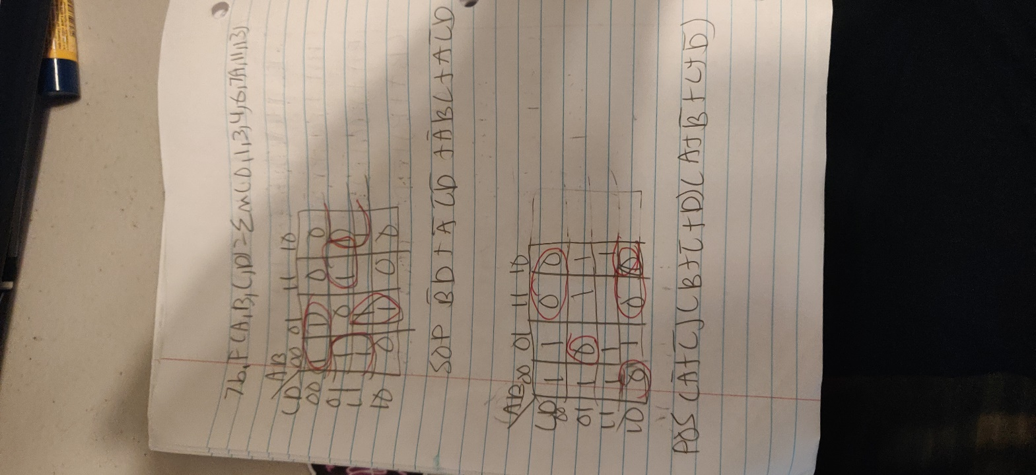

$F\left(A,B,C,D\right)=\left(A+\overline{B}+C\right)\left(\overline{B}+C+\overline{D}\right)\left(\overline{A}+\overline{B}+\overline{D}\right)\left(A+C+D\right)\left(\overline{A}+B+\overline{C}\right)\left(A+\overline{C}+D\right)$

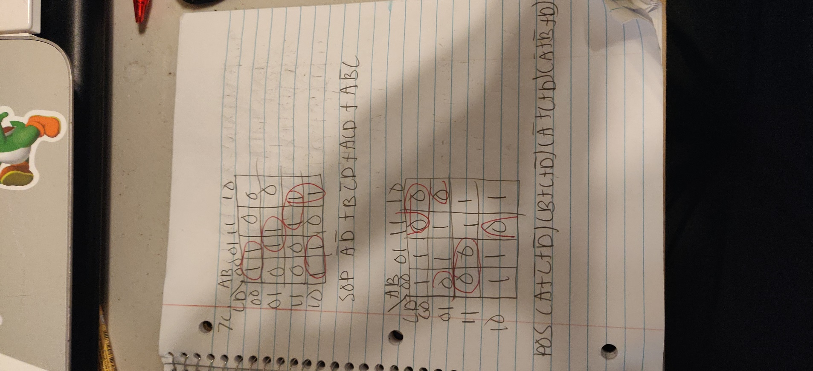

1. Draw a Logic diagram to represent the following function, draw the same Logic diagram only using NAND gates (4 points)

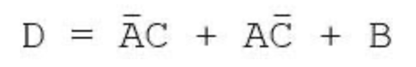

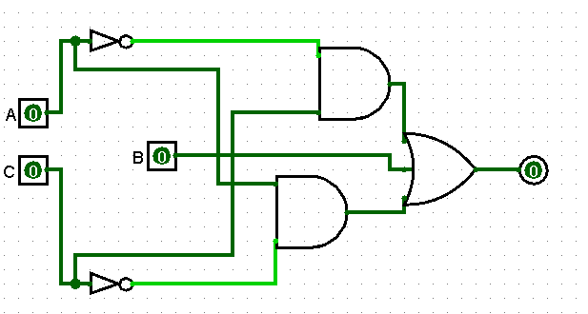

1. Calculate the complement of this function using one of the techniques you studied in class (3 points)

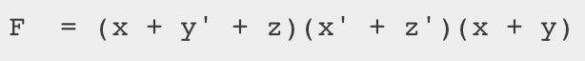

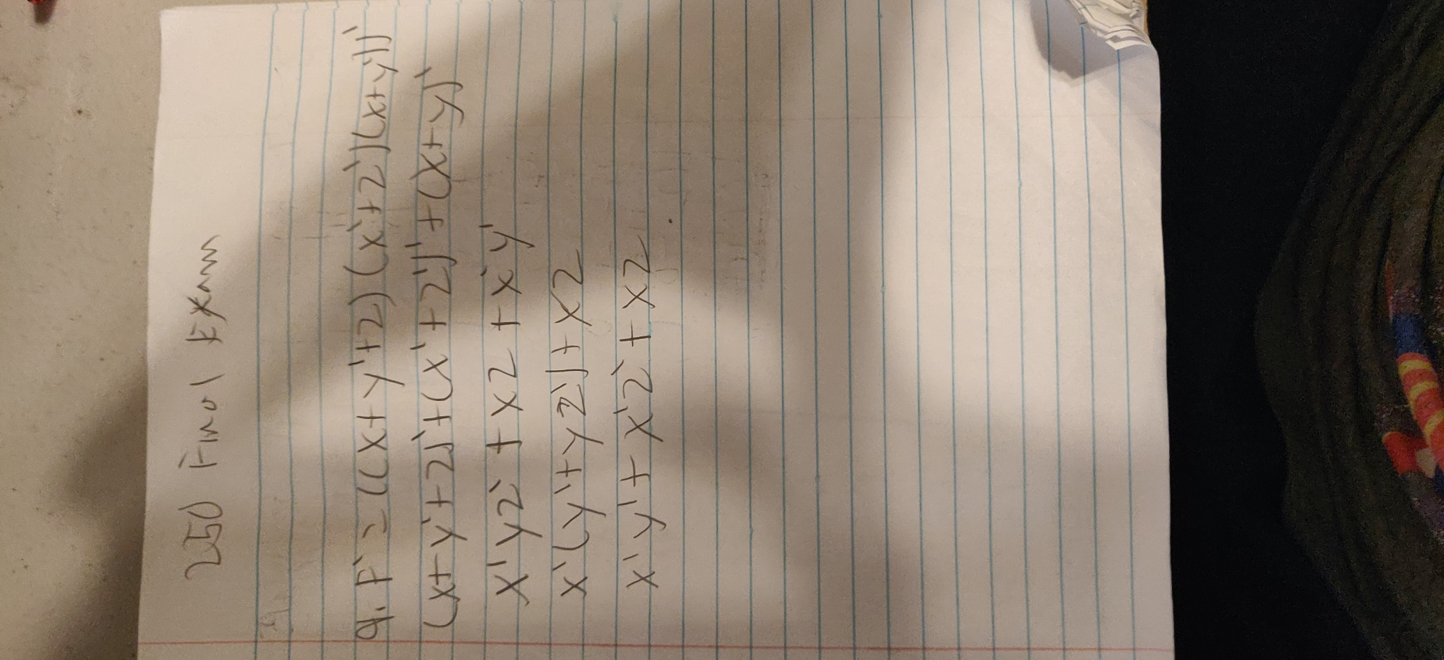

1. Derive the Boolean Function and the Truth table for the following Logic Diagram (5 points)

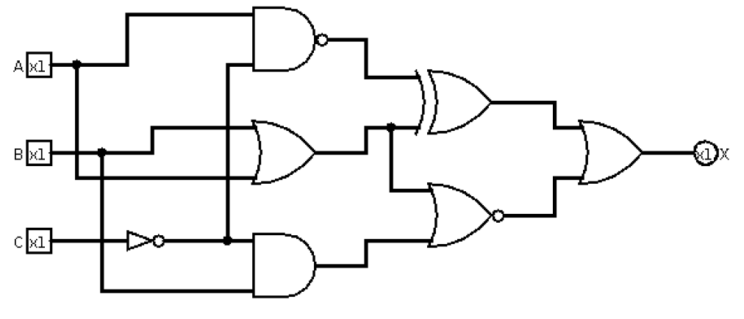

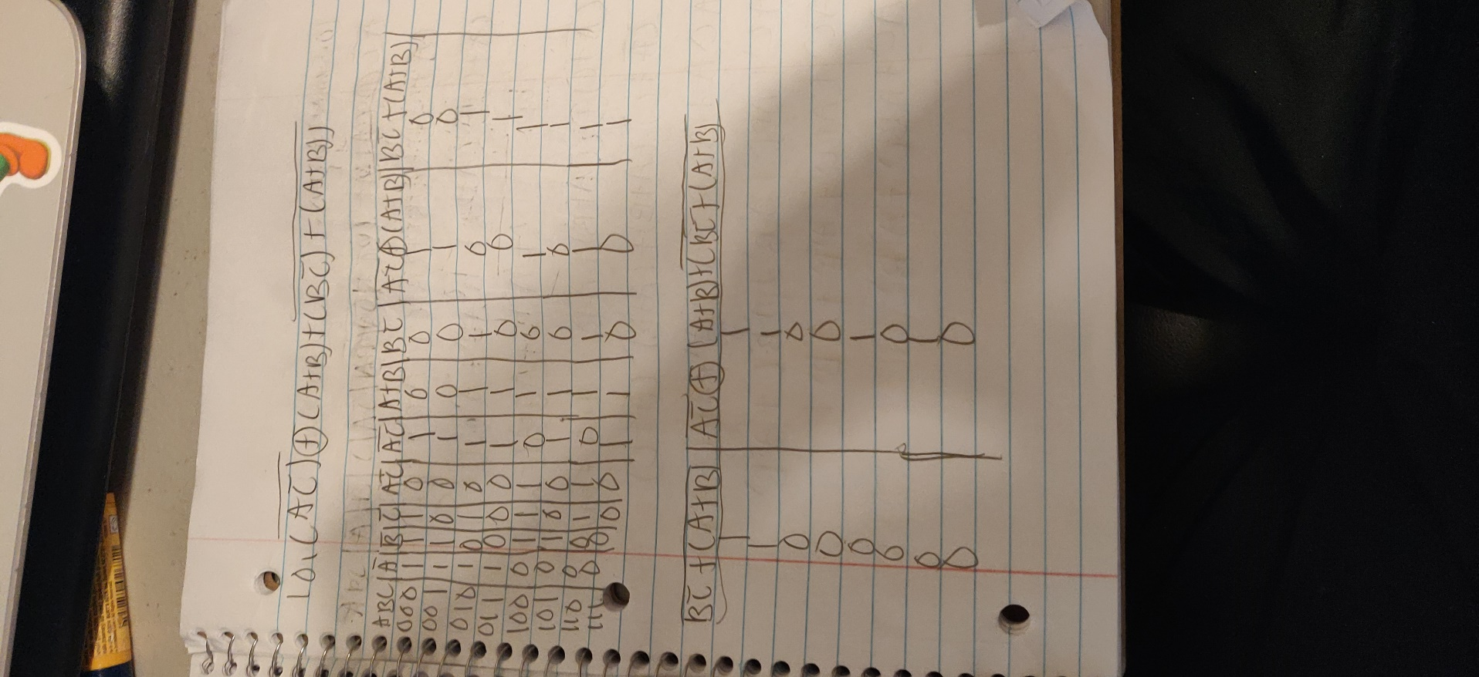

Simplify, find the simplified Boolean Function and draw the simplified version of the Logic Diagram.

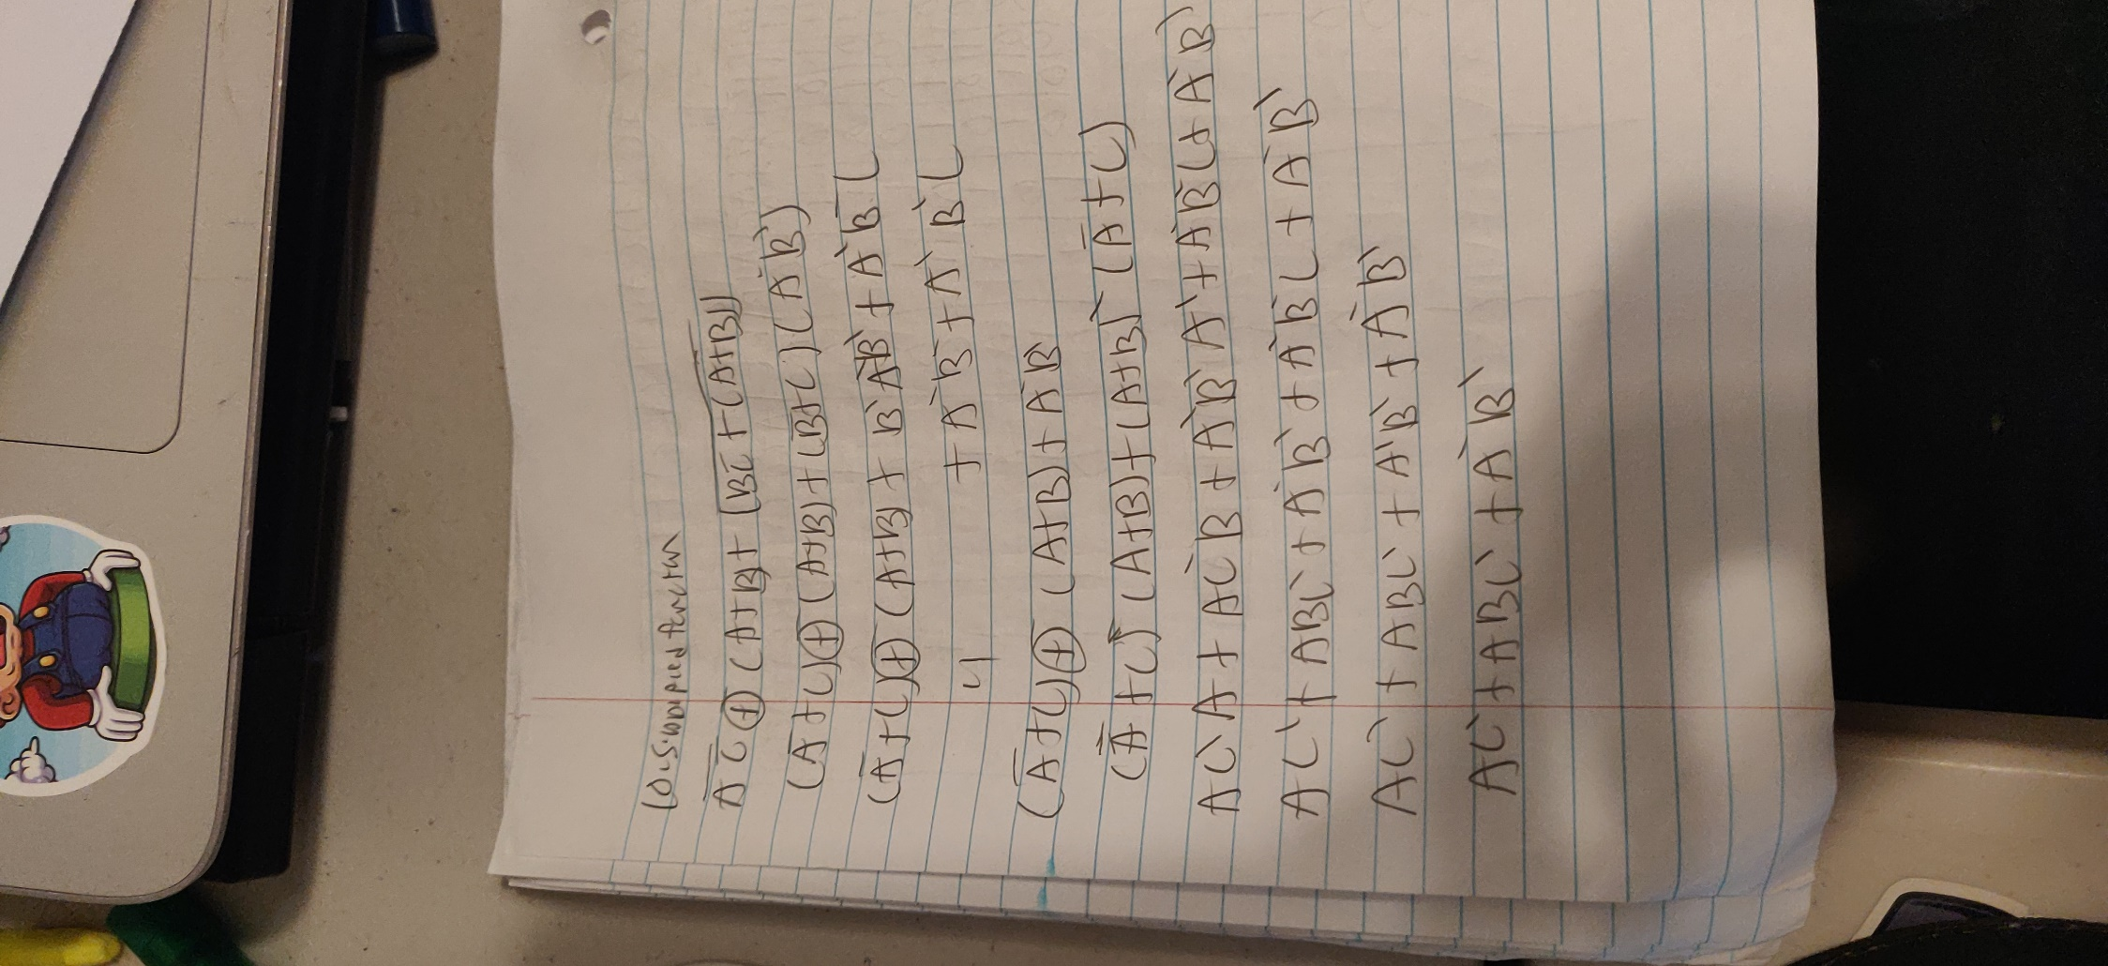

1. Construct the truth table, logical expressions, and circuit (using AND, OR, and NOT

gates) for the half-adder (3 points)

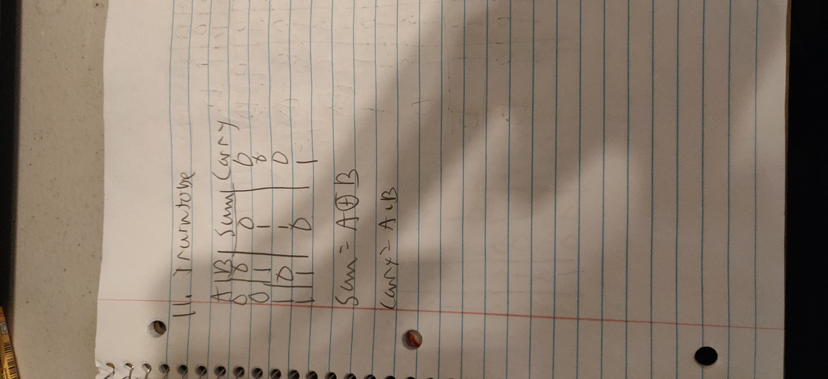

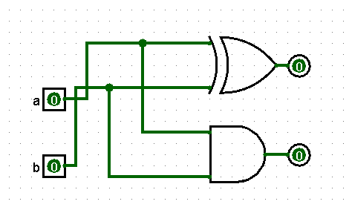

1. Use a 3-8 decoder to create a circuit with three inputs A, B, and C (thought of as the

binary number ABC) and two outputs, Even and Odd. If the number ABC is even

the Even output should be 1 and the Odd output should be 0. Similarly, if the number ABC is odd the Even output should be 0 and the Odd output should be 1 (5 points)

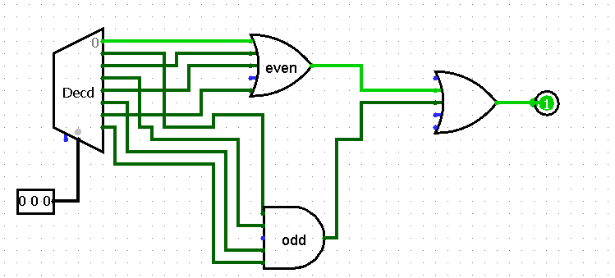

If an input number is even, outputs O0,2,4,6, are the outputs and they are high

Then for an even output signal, these outputs are given to the OR gate and its output is even

So for an Odd input, outputs O1,3,5,7, are the outputs and they are high

Then for an Odd output, these outputs are given to the OR gate and the output is odd

1. Implement the following Boolean Function with a Multiplexer and an inverter with the variable D as its input (4 points)



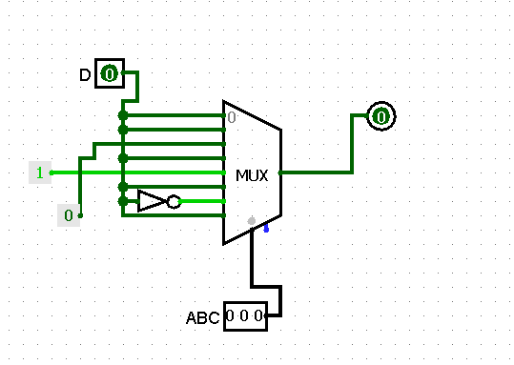

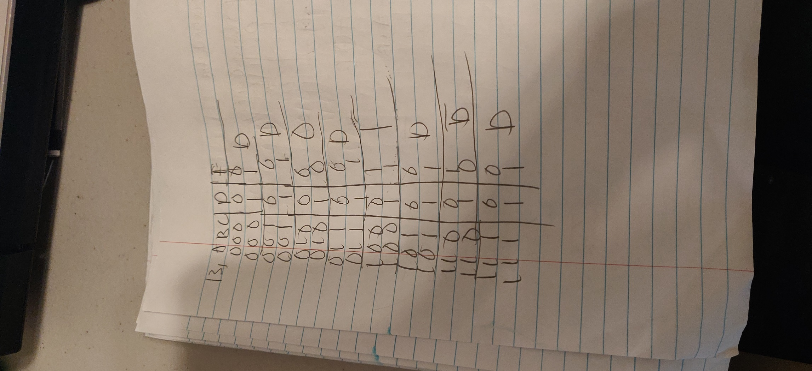

1. Explain the operation of a 4-bit shift register. Draw the logic diagram to help

explain its operation (3 points)

The purpose of the 4 bit shift register is that it is 4 flip flops connected in series

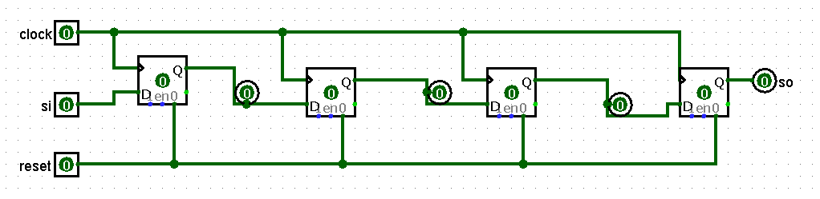

1. How can a JK flip-flop be used as a 1-bit memory storage device? Use this

configuration to build a 4-bit parallel data storage device (3 points)

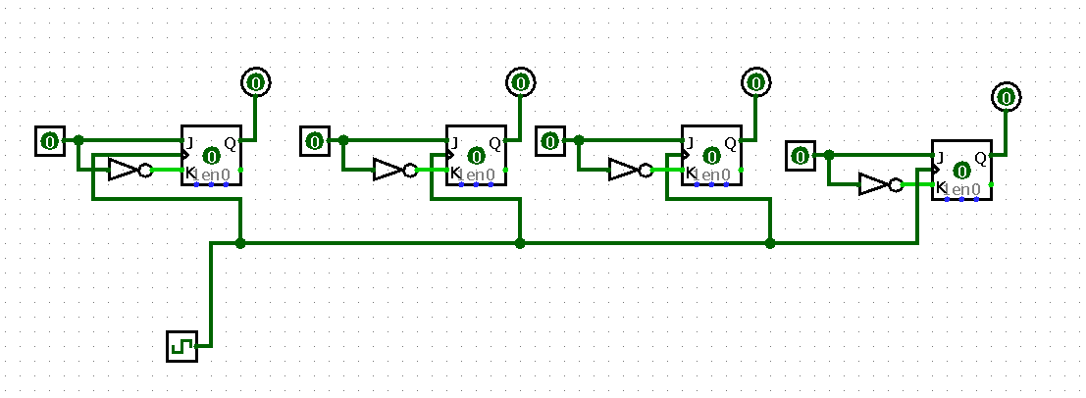

1. Derive the State Diagram and the Flip Flop input equations from the following State Table (10 points)

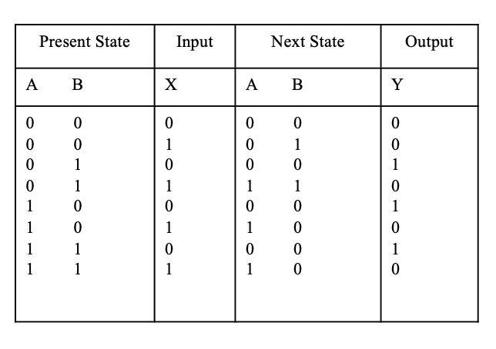

DA=AX+BX

DB=A’X

Y=(A+B)X’

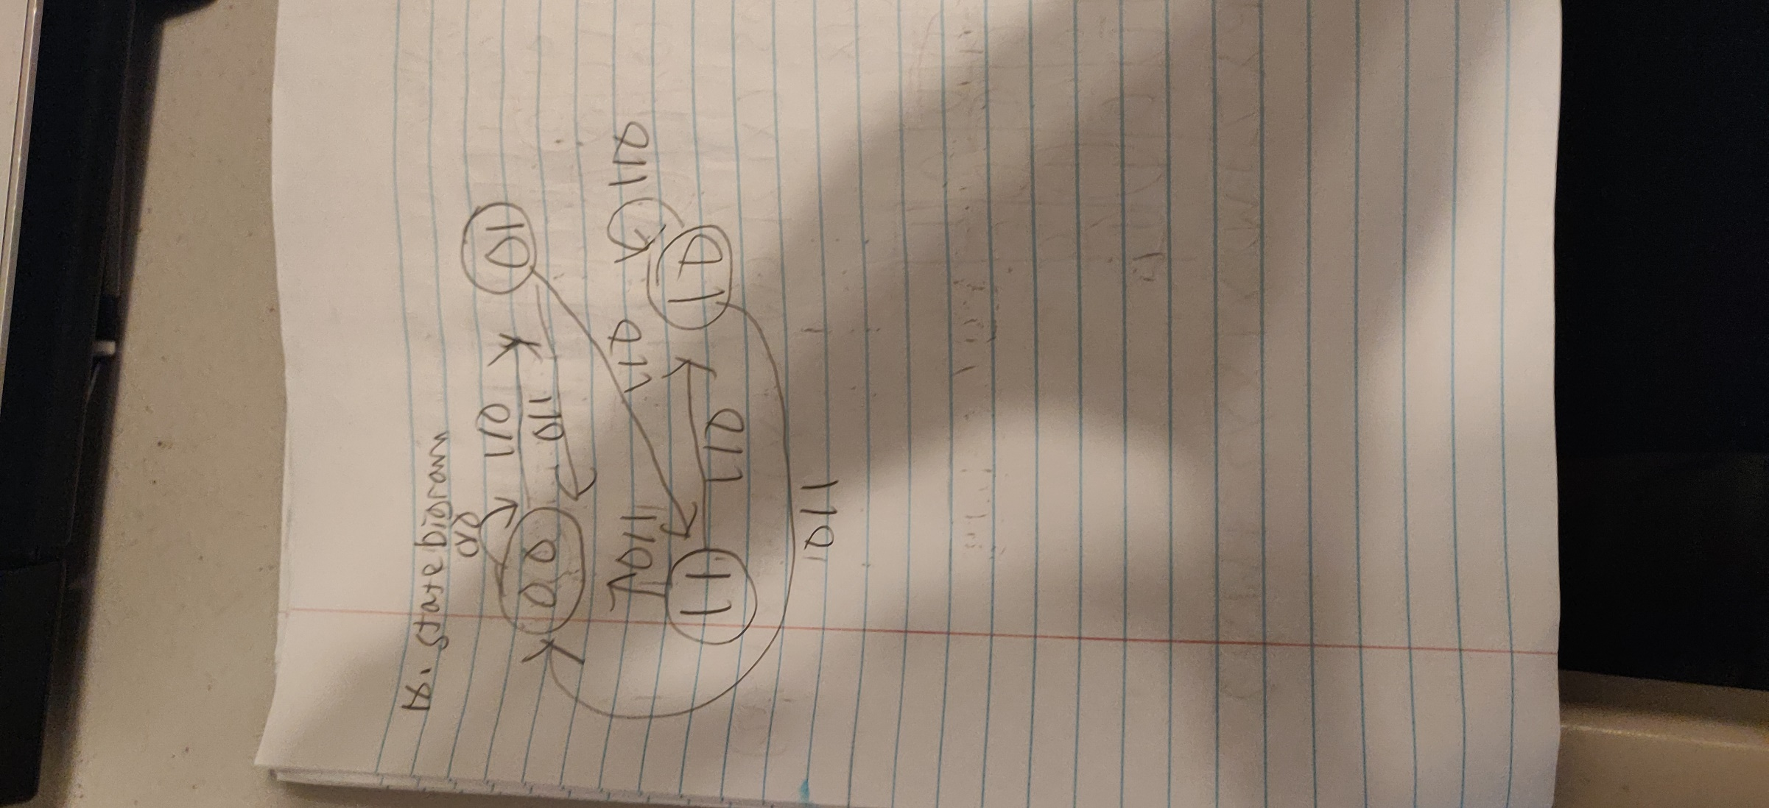

1. Using clocked JK flip-flops, construct a 4-bit counter (3 points)

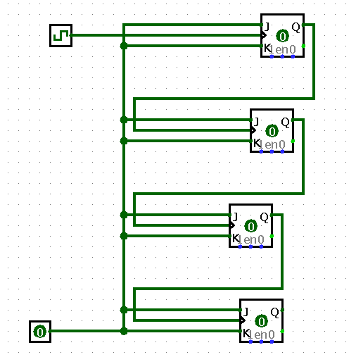

1. Derive the State Table and the State Diagram from the following Logic Diagram (10 points)